**Crud operations in mongodb**

**use my_project_db**

**show dbs**

**db.createCollection("mydb")**

**db.createCollection("movie")**

**db.movie.insert({"name":"Avengers: Endgame"})**

**db.movie.insert(**

**[**

**{“ name”: "Avengers: Infinity War" },**

**{ “name”: "Avengers: Endgame" }**

**]**

**)**

**db.developers.insertMany(**

**[**

**{ _id: 20, devname: "John Wick", tools: "Visual Studio", born: 1948 },**

**{ _id: 21, devname: "Ganesh Roy", tools: "Net Beans", born: 1945 },**

**{ _id: 22, devname: "Deeksha Raul", tools: "Unity 3D", born: 1954 }**

**]**

**)**

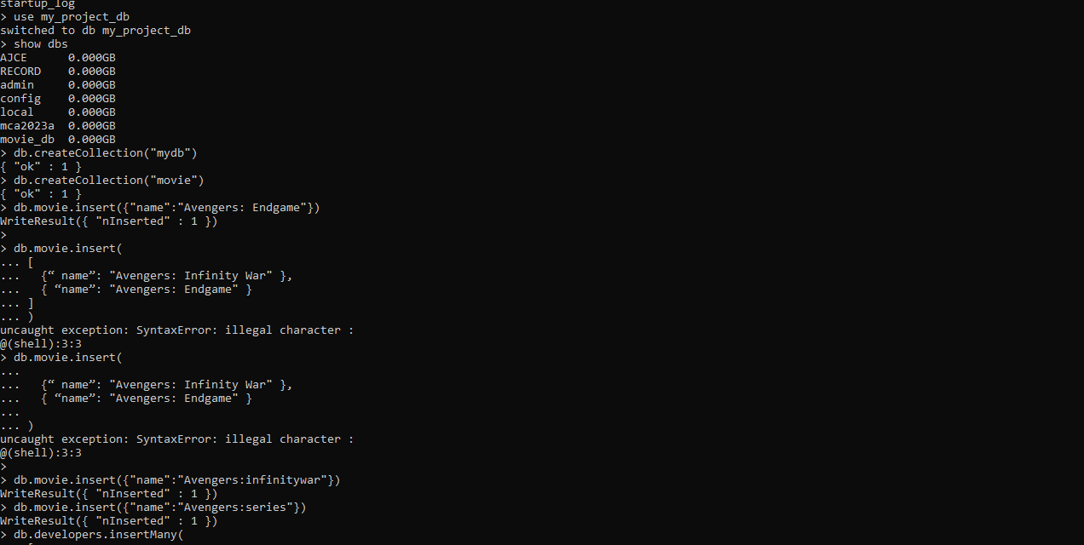

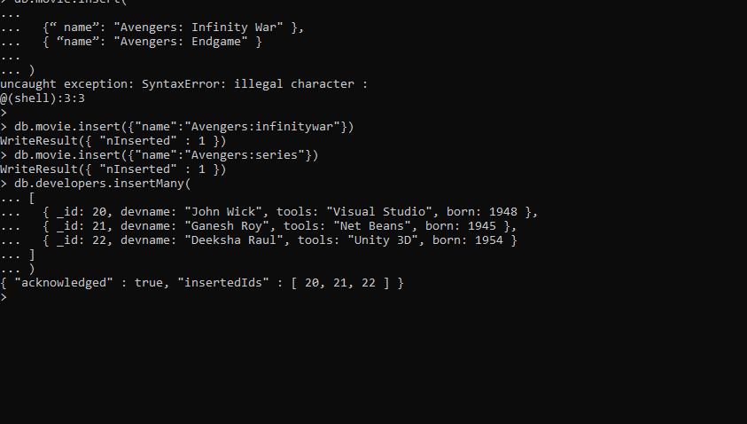

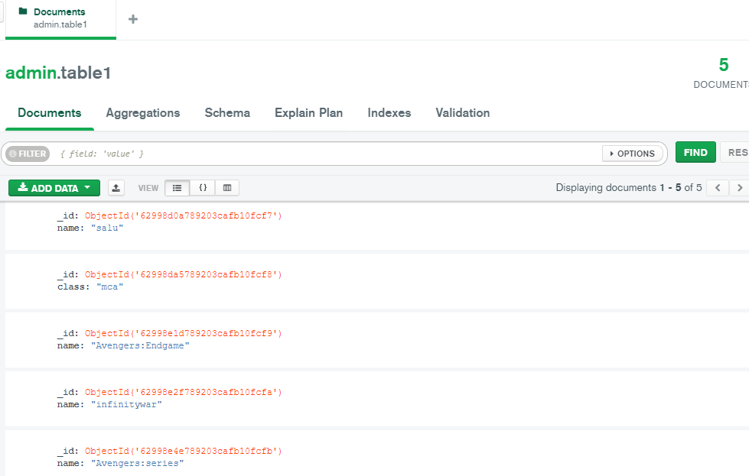

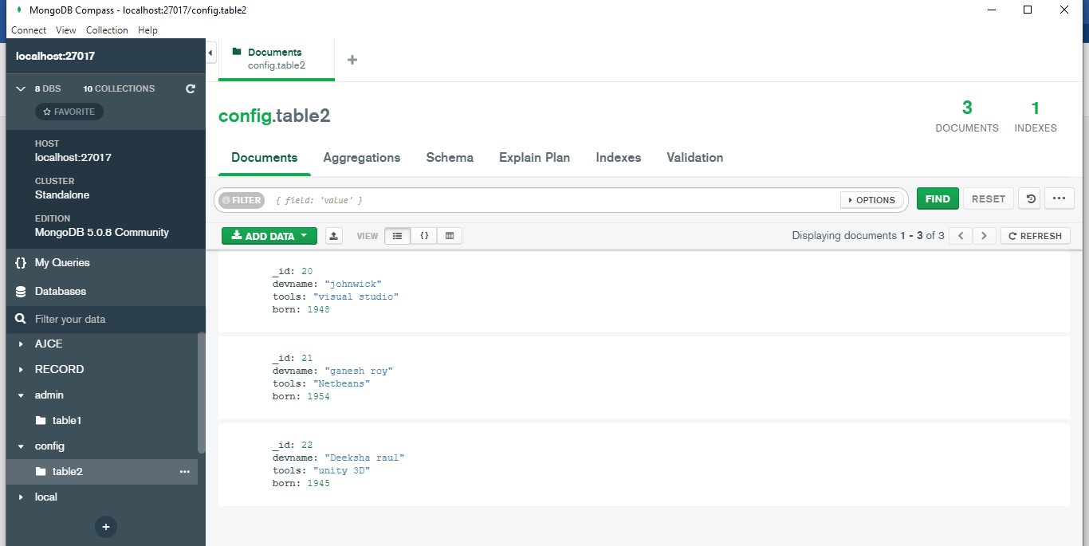

**Read Operations**

db.table1.find()

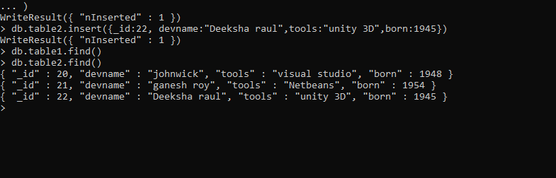

**Update**

Use database name

Db.table2.update({“_id”:20,{set:{“tools”:”java1}})

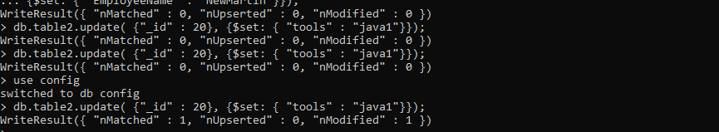

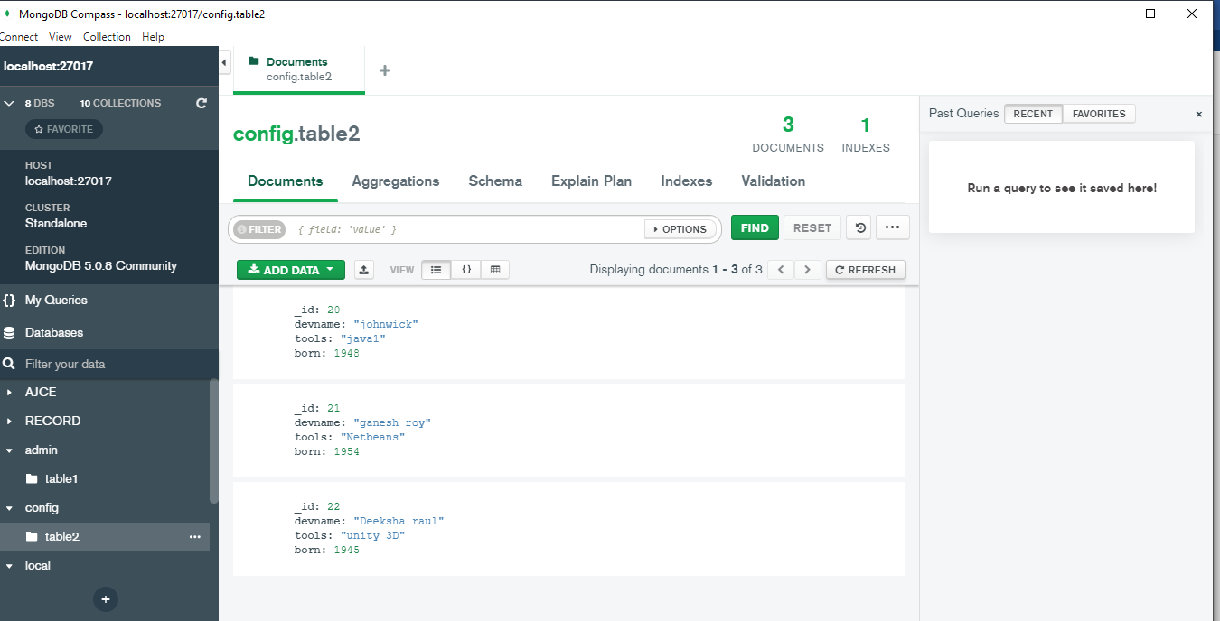

**Delete**

Db.table2.deleteOne({“_id”:21})

